# UGScan User Guide

V1.0

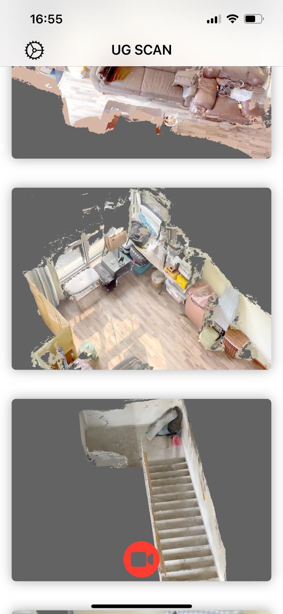

Press open 3d view

Long Press open option menu

Start new scan

Settings

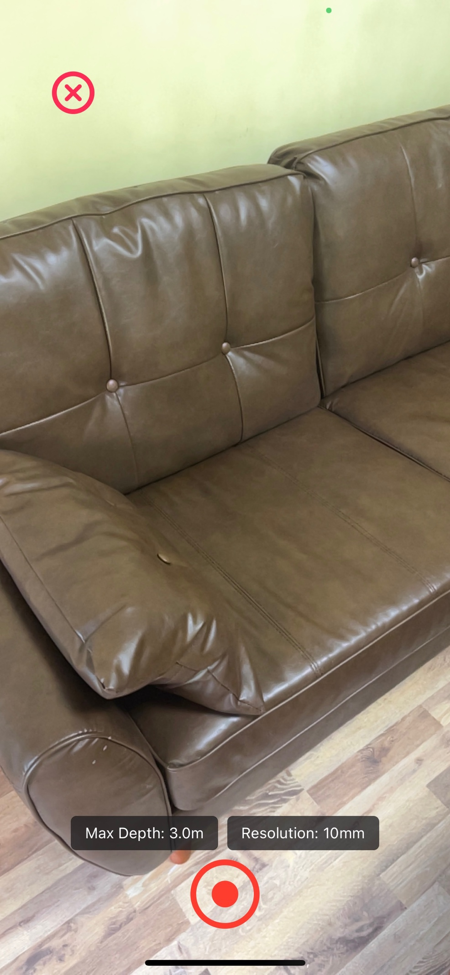

Change voxel resolution

Change max depth

Start new scan

Stop and close Scan view

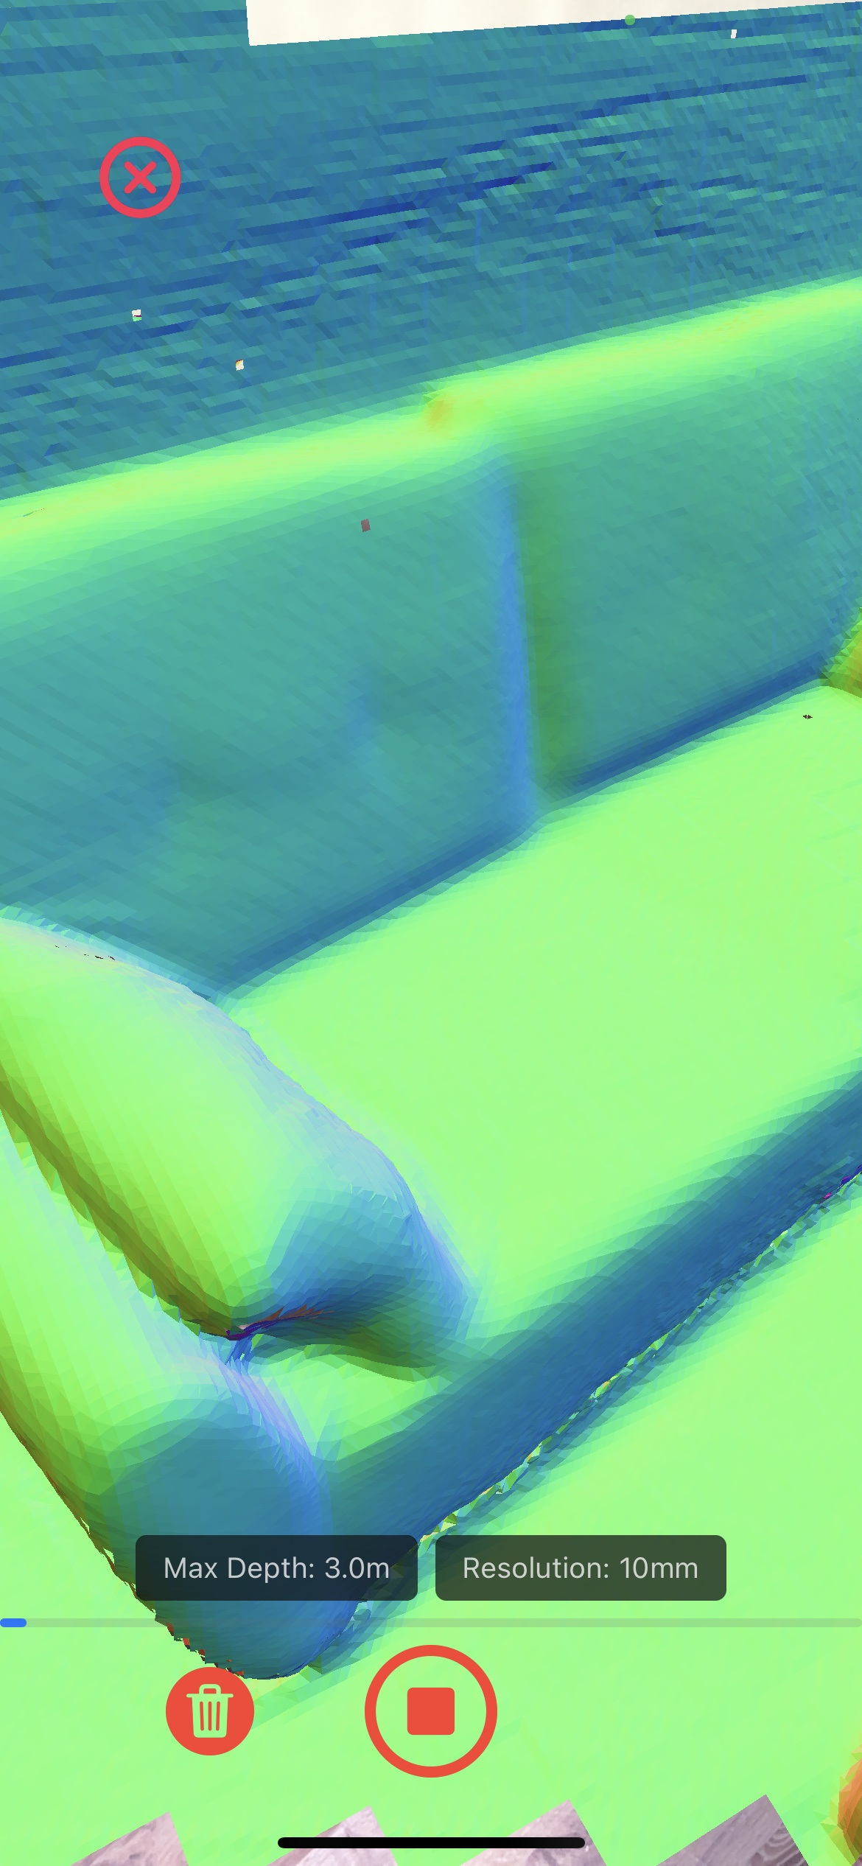

Stop and save Scan

Delete current scan

Reset the states

Normal color of mesh

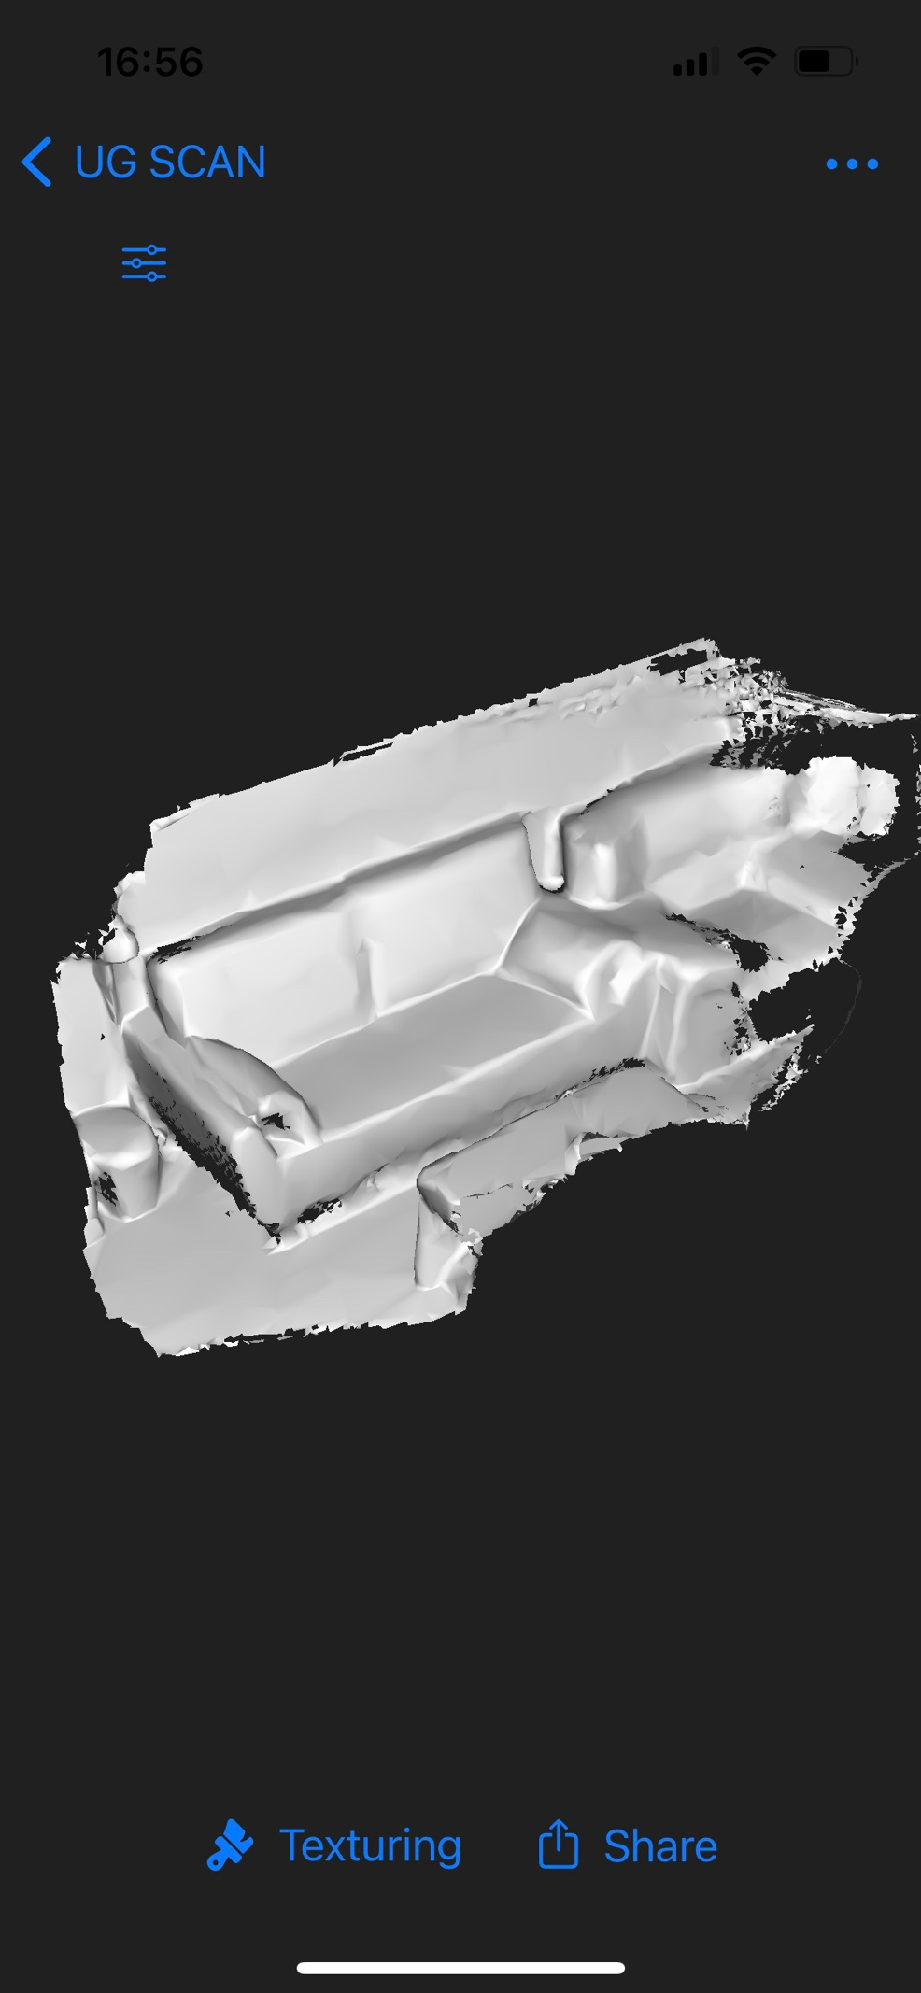

Rendering mode

Export and share

Generate Textures

3D View

Select format for exporting

